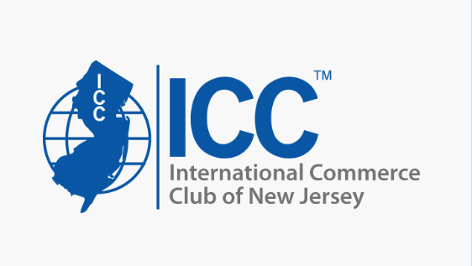
2026 ESSAY GUIDELINES

We are pleased to announce The International Commerce Club of New Jersey will once again award a scholarship to each to three winning candidates who submit the best overall essay and whose academic standing is exemplary. The 2026 awards will be on award each for graduate and undergraduate schools and a 3rd award for either school. The winners will be selected based on evaluation of all submissions and presentation will be made at our ICC NJ Annual Industry Night Dinner, this year is scheduled for November 19, 2026 at Galloping Hill Country Club.

Special consideration will be given to a student in an International Business program or a related major, e.g. transportation, logistics or supply chain management. Consideration will also be given to ICC-NJ Club members (must be in good standing) and their immediate families.

Eligible candidates must meet the following requirements:
• New applicants per scholarship category must be enrolled as an undergraduate or graduate student as of the 2026 fall term at Rutgers University. If applicant is an ICC NJ member or the child of an ICC of NJ member, student must be enrolled as an undergraduate or graduate student at a local NJ accredited collage as of the 2026 fall.
• Applicant must have completed at least one year of college or university studies and maintained at least a “B” average (3.0 equivalent). Applicants are required to submit a recent copy of their transcript to demonstrate same.
• Applicant must complete:
- The ICC scholarship application (attached).
- A. biography explaining why the applicant has chosen thier field of study and outline student objectives.
• Applicant must submit an essay addressing one of the listed essay topics and meeting the essay guidelines.
- Original content only, no AI generated material permitted.
- All submissions and matters are considered final and confidential.

We invite you to complete the Application Form and submit it together with your Transcript Copy, biography and Essay Submission by: October 29, 2026. Winners announced week of September 15, 2026. Electronic Submissions to both; zach942@prodigy.net and moore.richard@zim.com
Any questions please contact, Michael Zachariades 732-371-9158 Richard Moore 856-651-8668

Good Luck!

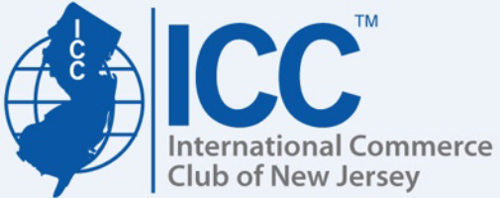
INTERNATIONAL COMMERCE CLUB
OF NEW JERSEY
2026 SCHOLARSHIP APPLICATION

APPLICANT’S FULL NAME _________________________________________________________
PHONE _________________________
RUTGERS EMAIL __________________________________________
PERSONAL EMAIL_________________________________________
COLLEGE / UNIVERSITY _________________________________________________________
CITY __________________________ STATE ____________
MAJOR FIELD _____________ CURRENT CLASS STATUS ________ DEGREE DATE ______
HOME ADDRESS ________________________________________________________________
SCHOOL ADDRESS ________________________________________________________________
NUMBER OF CREDITS YOU PLAN TO COMPLETE IN THE NEXT ACADEMIC YEAR _________
CUMMULATIVE POINT OR GRADE AVERAGE AT PRESENT ____________________________
HIGH SCHOOL ATTENDED _________________________________________________________
OTHER COLLEGES / UNIVERSITIES ATTENDED Please indicate years spent at each school and location
____________________________________________________________________________________
____________________________________________________________________________________

WHAT COLLEGE SCHOLARSHIP OR HONORS HAVE YOU HELD (Please indicate dates)
_____________________________________________________________________________________

LIST THE EXTRACURRICULAR AND OUT OF SCHOOL ACTIVITIES IN WHICH YOU
PARTICIPATE, THE ORGANIZATIONS YOU BELONG TO AND ANY OFFICES HELD THEREIN.
(For example – church groups, student societies, publication staffs, etc.)
________________________________________________________________________________________________________________________________________________________________________
____________________________________________________________________________________

PLEASE TELL US WHY YOU HAVE CHOSEN YOUR FIELD OF STUDY INCLUDING YOUR
CAREER OBJECTIVES. PLEASE BE AS DESCRIPTIVE AND SPECIFIC AS POSSIBLE.
____________________________________________________________________________________
____________________________________________________________________________________
____________________________________________________________________________________

ICC OF NJ MEMBER: (please circle) APPLICANT? YES / NO PARENT? YES / NO
PARENT’S OR GUARDIAN’S NAME ____________________________________________________
PHONE _________________________ EMAIL __________________________________________
HOME ADDRESS _____________________________________________________________________

